**Open Society Myanmar Foundation**

**Narrative Interim/Final Report**

Template and Guidelines

***1. Grant Information***

|  |  |
| --- | --- |
| Organization | Phoenix Association |
| Grant No # | OR2019-61222 |
| Address | No. 158 (D), Htee Hlaing Shin (1) Street, Htee Hlaing Shin Housing, Ward (8), Hlaing Thar Yar Township |
| Primary Contact Name | U AUNG HEIN HTUN |
| Telephone # | +95 9 420 60 6767 |
| e-mail | po.phoenix.ygn@gmail.com |
| Total Grant amount received | 70,000 USD |
| Amount spent (USD) | 60,209 USD |
| Project start date and end date | 01 July 2019 – 30 June 2021. |
| Reporting Period | 01 July 2019 – 30 June 2020 |
| Location of project | Yangon, Mandalay and Naypyidaw |

* 1. ***Project Overview for Reporting Period***

*Phoenix Association started activities in 2005 related to HIV/AIDS matters and official approval from Myanmar government was achieved in 2012 as a local non-governmental organization. In addition to care and support activities on HIV/AIDS, the organization found out legal and human rights issues among key populations affected by HIV/AIDS. Therefore, Phoenix Association started involving in legal and justice issues and started ‘Access to Justice’ program in 2012. Since then, the association continued to involve in advocacy, law making and reforms and policy matters.*

*Regarding with people who use drugs/inject drugs (PWUD/PWIDs), this population faces various barriers in accessing services as well as legal and justice issues as a consequence of criminalization of drug use in the context of political instabilities. While law enforcement approaches are tough and punitive in nature, misconceptions and judgmental attitudes are prevalent among various stakeholders. Therefore, the association planned to implement this project to improve enabling environment related to drug problem in Myanmar with funding support from Open Society Myanmar.*

*Though the first remittance of funding from OSM was received on 08 October 2019, Phoenix association started activities since July 2019 for the project start up with the approval of OSM.*

*Activities of the year 1 of the project are:*

* *Project launching and staff capacity building*
* *Advocacy meetings with Hluttaw committees and a meeting with high-level personnel (One high-level meeting and 2 advocacy meetings with hluttaw committees)*
* *Awareness raising workshops with parliamentarians (1 workshop with legal communities in Yangon, 3 workshops with parliamentarians – 1 each in Yangon, Mandalay and Naypyidaw)*
* *Organizational development workshop*
* *Monitoring and evaluation of activities*
* *Website development and maintenance*
* *IEC development*
* *Decriminalization booklet production*

***3. ACTIVITIES***

***3.1 Completed Activities***

* ***Project launching and staff capacity building***

*With the approval of OSM, the project start-up activities were initiated after 01 July 2019. In August 2019, Phoenix association organized two training events for project staff; Drug policy and law training, and communications and advocacy training.*

***Drug policy and law training****: This training was attended by 19 participants including those from Mon News Agency and staffs from Alinthit association.*

*Training topics covered drugs and addiction, policy approaches, supply reduction, demand reduction covering drug use prevention and treatment, harm reduction, human rights and drug use, Myanmar National Drug Control Policy and Myanmar drug law (The amending law of Narcotic drugs and Psychotropic Substances Law of 1993). One day training was conducted by Dr. Htwe Kyu, the technical consultant for the project.*

*There were pre-test and post-tests and the scoring was as below;*

*Total scoring of pre-test = 48.89%*

*Total scoring of post-test = 69%*

|  |  |  |
| --- | --- | --- |
|  | *Minimum*  *score* | *Maximum*  *score* |
| *Pre – test* | *1* | *5* |
| *Post – test* | *7* | *9* |

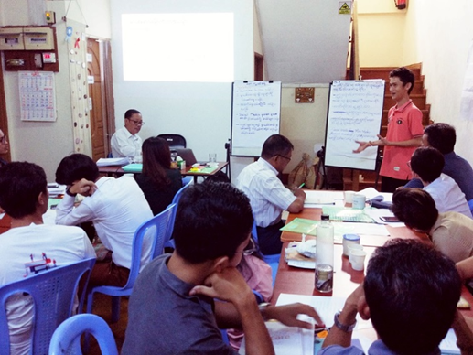

Figure 1:Drug policy & Law training

***Communication and advocacy training:*** *The training was conducted by U Nay Lin as one day training event. Regarding with advocacy, the trainer discussed about advocacy process and its components. Then, advocacy framework was discussed with interactive activities. With regards to communication, the trainer discussed about effective communication steps and brainstormed with participants. Pre- and post-tests were done and scoring was 58.89% in pre-test and 89% in post-tests.*

***The launching event of the project***

*Project launching activity was held on 19 November 2019 at the Central Hotel in Yangon. At the opening event, the Executive Director of Phoenix association presented about Phoenix’s programs and the technical consultant presented about the project activities. The technical consultant presented about drug abuse situation across the world and its ill consequences, the problem situation in Myanmar and the need to understand policy approaches due to widespread misconceptions as a rational for implementing the project. He also explained about target beneficiaries of the project which included parliamentarians, members of political parties, legal aid groups and lawyers and media personnel.*

*The Chairperson of Social Affairs and Management Committee of Yangon Region Hluttaw provided opening remarks. He welcomed the activities as drug abuse problem was widespread and should be taken as a national concern. He also invited to organize workshop with Yangon Region hluttaw parliamentarians. Also, a member of SNLD Party (Shan Nationalities League for Democracy) discussed with her experiences as well as U Tin Maung Oo from Union Betterment Party discussed and added with their experiences. Participants from political parties, legal aid groups, UNODC (United Nations Office on Drugs & Crime), National AIDS Program, NGOs, Civil Society Groups, National Drug User Network Myanmar (NDNM), Asian Harm Reduction Network (AHRN)and key population groups attended the event.*

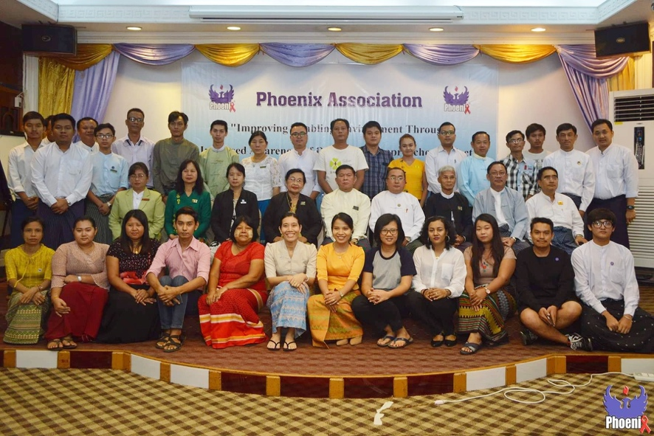

*Figure 2: The launching event of the project*

***Staff capacity building****: With regards to capacity building, one staff is supported for accounting (ACCA part 1) and 2 staffs for administration training. In addition, self-assessment training by CBI and child safeguarding policy training was also arranged in Phoenix office. Regarding with finance, review of financial matters and provided a training on finance system and financial procedures was organized for the staffs.*

* *Advocacy meetings with Hluttaw committees and a meeting with high-level personnel*

*Phoenix association planned two advocacy meetings with hluttaw committees and a meeting with high-level personnel in Year 1 of the project. Therefore, Phoenix association submitted requests for a meeting with the Speaker of Pyidaungsu Hluttaw and a meeting with the joint bill committee of Pyidaungsu Hluttaw. The office of Pyidaungsu Hluttaw replied to combine above 2 meetings into one and to meet together. Therefore, the advocacy meeting was held on 06 December 2019* *at Pyidaungsu Hluttaw office. During the meeting, the participants discussed about the amending law of Narcotic Drugs and Psychotropic Substances Law of 1993, as amended on 14 February 2018. Along with Phoenix association, the representatives from OSM, Alinthit Social Development Association and National Drug User Network Myanmar (NDNM) also participated. The participant discussed about barriers and constraints experienced related to the amended law with on ground situations. Dr. Htwe Kyu, the technical consultant, and U Kyaw Sein, an Advocate and retired deputy Director General of Attorney General’s Office, explained about the need to revise the law which should be repealed and should draft a new law as the amended law had about 40 areas of amendments while the original law had only 31 articles as it was contradict with legal drafting practices.*

*The joint bill committee team also explained about the timing related to forthcoming election period and also provided suggestions for the way forward.*

*Participant List*

|  |  |  |
| --- | --- | --- |
| **Team** | **Name** | **Designation** |
| Joint Bill Committee | U Htun Htun Hein | Chair of Joint Bill Committee, Vice Chair of Pyithu Hluttaw |
| U Zaw Min | Chair of Amyotha Hluttaw Bill Committee |
| U Khin Maung Win | Chair of Pyithu Hluttaw Bill Committee |
| U Kyaw Soe Lin | Secretary of Pyithu Hluttaw Bill Committee |
| Dr. Myat Nyana Soe | Secretary of Joint Bill Committee and Amyotha Hluttaw Bill Committee |
| Phoenix Association | U Thiha Kyaing | Executive Director |
| U Kyaw Sein | Advocate & Notary Public |
| Dr. Htwe Kyu | Consultant |
| Dr. Sithu Htin Aung | Open Society Myanmar |
| U Heinn Khant | Alinthit Association |
| U Zaw Moe Naing | Liaison Officer, Phoenix Association |

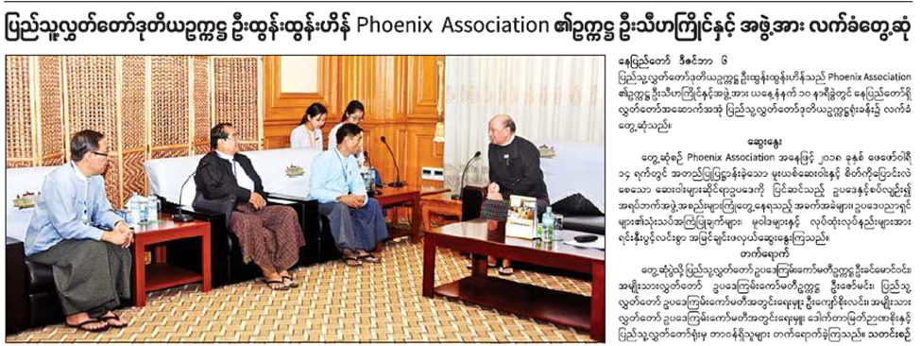

*Figure 3: Advocacy meetings with Hluttaw committees and a meeting with high-*

*level personnel at Pyidaungsu Hluttaw office*

* ***Organization development workshop***

*According the project workplan, Phoenix association organized organization development workshops in Yangon and Mandalay. The strategic planning workshop was held in Yangon on 10 December 2019 and board members of Phoenix association, technical advisors, members of the association, project staffs and volunteer groups participated. Current organization structure, vision, missions were reviewed and adopted to revise vision, mission statements and objectives to be in accord with activities as well as to reflect the status of the association and future activities.*

*The second workshop was held in Mandalay on 14-15 December 2019 and participated by those who involved since the set up of the association as well as technical advisors, members of Phoenix association, project staffs and volunteer groups. In that workshop, the participants brainstormed to formulate new vision, missions and objectives and as a result, new statements were developed. Results can be seen as below;*

|  |  |  |
| --- | --- | --- |
|  | *Former statement* | *New statements* |
| *Vision* | *Under-privileged people in Myanmar can cope with their basic needs in social, economic and health by 2050 and they will be able to stand on their own feet.* | *“Self-Resilient Right-Based Justice Society”* |
| *Mission* | *Phoenix Association, as a local social organization, provides assistance to under-privileged people regardless of their ethnic or religion to lessen their needs in social, economic and health through scholarships, income generation activities, awareness and vocational training and networking.* | *“Self-Resilient and Social Justice for Health”* |
| *Objectives* | *1. To build up People living with HIV, their family, and other community members to be self-sufficient with positive living, and provide help for their health, economic, education, and social needs*  *2. To response timely to help for disaster-affected areas and emergency needs*  *3. To provide help consistently to those in need with the income from Phoenix income generating activities* | * *To promote justice and rules of law in HIV-related health and other sectors.* * *To coordinate with authorities, respective organizations and networks for justice and secure environments.* * *To improve capacities for youth and other necessary human resources to take leadership role in promoting justice and rule of law.* |

*As a result of organizational development activity, PRLM (Promoting Rule of Law in Myanmar) of USAID also agreed to support to implement changes and Child Fund Myanmar also agreed to provide technical supports related to child protection activities.*

* ***Monitoring and evaluation***

*Monthly staff meetings were held in Phoenix office with project team and reviewed activities and discussed workplans. After COVID-19 period with restrictions of movement, staff meetings were held via online meeting arrangements.*

*Preparatory meeting for monitoring & evaluation was held on 15 May 2019 with online arrangement. Senior management team and project team members participated in the meeting. Participants agreed to conduct on 13 June 2020 and to conduct via online arrangement due to COVID-19 situation.*

*M&E workshop: Due to COVID-19 situations, M&E workshop was held via online arrangement with 10 participants. Amongst planned activities in year 1, activities related to awareness raising workshops (Drug policy workshops) and one advocacy activity with a Hluttaw committee was postponed due to COVID-19. Regarding with capacity of staffs, it was found that delayed reporting and incompleteness though they activity participated in activities. Regarding with financial management, proper management of resources was found but there was a need to develop skills of accounts and another factor related to budget was late acceptance funding support as it received on 08 October 2019 though the project starting date was mentioned on 01 July 2019. As a result of M&E workshop, the participants agreed;*

* *Due to COVID-19, workplan should be revised.*
* *Regarding with target beneficiaries, workplans should be taking into account of government changes related to elections and the new government.*
* *Management teams should prepare risk management plans in remaining period of project implementation.*
* *Management committee to consider capacity building of staffs and also taking inputs from the consultant.*
* ***Website development and maintenance***

*Administrative and Human Resource Manager and office team worked together with technicians to develop Phoenix association’s webpage. With the support of OSM, Phoenix association is able to provide subscription fees for website maintenance and a staff from Phoenix association can update activities regularly themselves.*

* ***IEC Development***

*The project team planned to distribute memory sticks printed with information over the sticks. Though it was planned to make 1,000 sticks, the project created only 200 pieces as there were budget limitations in Year 1 and will create remaining in the year 2.*

* ***Decriminalization booklet development***

*The project planned to produce a booklet on ‘Decriminalization of drug use and personal possession’. The technical consultant compiled the book and the activity finished in May 2020. Therefore, 10,000 copies of the booklet were printed in the year 1.*

***3.2 Postpone Activities***

* *Among planned activities for year 1, an advocacy meeting with Hluttaw committees was cancelled due to the epidemic of COVID-19. Phoenix team planned to meet with ‘Public Management Committee’ of Pyithu Hlutttaw and already agreed the plan by Hluttaw Office but it had to be cancelled due to imposition of movement restrictions for COVID-19 epidemic.*

|  |  |
| --- | --- |
| ***Planned*** | ***Postponed*** |
| *1 advocacy meeting with high-level* | *Done* |
| *1 meeting with Hluttaw committes*  *(meeting with Joint bill committee)* | *Done* |
| *1 meeting with a Hluttaw committee*  *(Meeting with Public Management Committee)* | *Postponed due to COVID-19* |

* *Similarly, 4 awareness raising workshops with legal communities and parliamentarians were also postponed due to COVID****-****19 pandemic.*
* ***Unplanned activities carried out***
* *Printing of ‘Unbalanced report (Review of National Drug Control Policy against Myanmar Drug Law): Instead of printing with high cost paper for the decriminalization booklet, the consultant considered to print with moderate quality paper (Wood free paper). Therefore, initial calculated cost for the printing of booklet was reduced and the surplus fund from the respective budget was used to print 300 copies of ‘Drug Law and Policy review report’ after informing to OSM office. The report copies will also be distributed during advocacy meetings and training workshops.*
* *Distribution of infection prevention materials for COVID-19: During restriction period laid down by the Government, communities in Hlaing Thaya area where the office of Phoenix association located were in need of support for prevention of COVID-19. Therefore, Phoenix team informed to OSM for prevention interventions as a cross cutting problem and to allow using existing fund in small amounts via email and OSM also replied for approval. Then, Phoenix staffs distributed soaps for hand washing and information on prevention was also distributed with pamphlets at motor bike stands, markets and bus stops. Those information pamphlets were especially attracted attention of communities.*

***4. EVALUATION***

***4.1 Objectives***

*As the project activities are training workshops and meetings, all has to be stopped related to COVID-19 restrictions and the objectives of the project were yet to be met.*

***4.2 Project design and Implementation***

* *In retrospect, project objectives can be viewed as realistic and also necessary for the drug related issues which was also commented by the technical director of AHRN (Asian Harm Reduction Network) which is implementing harm reduction activities widely across the country.*
* *As Phoenix association involved in law and policy making processes, politicians and parliamentarians knew well of Phoenix association and the intended activities are achievable and manageable.*
* *Apart from experiencing with COVID-19, there are no specific difficulties to implement activities.*

***4.3 Impact on beneficiaries***

*As the implementation of activities are interrupted by COVID-19, the impact upon target beneficiaries is not possible to mention.*

***4.4 Way Forward***

*Phoenix team is looking into feasibilities to resume activities in August 2020 based on easing of restrictions by the Government. Please see below for the way forward;*

|  |  |  |
| --- | --- | --- |
| *Activities* | *Way forward* | *Remark* |
| *1 meeting with a Hluttaw committee* | *2021* | *Postponed activity and may be feasible only in new government term.* |
| *1 high-level advocacy meeting* | *2021* | *This is year 2 plan and will implement in new government term* |
| *8 Drug policy workshops* | *2020 – 2021:*  *8 training workshops* |  |
| *2 sessions with legal communities* | *1 session was postponed from year 1* |
| *3 sessions with parliamentarians* | *(Yangon, Mandalay, Naypytiaw)*  *3 sessions are postponed from year 1 due to COVID-19* |
| *1 session with members of political parties* |  |
| *2 sessions with media personnel* |  |

***4.5 Success stories***

*Replication of activities: During launching ceremony of this project, AHRN technical director discussed with the Executive Director of Phoenix association about future activities. Being an organization working widely in the area of harm reduction in Myanmar, AHRN told they would like to replicate similar activities in their project areas. The technical director explained to the technical consultant of Phoenix association that such activity was necessary and they would try to implement in field levels to complement Phoenix’s activities.*

***5. ADDITIONAL COMMENTS***

*As there are postponed activities due to COVID-19, there are also unspent funds accordingly. As Phoenix association will implement postponed activities in year 2 of the project, initial approved budget will remain unchanged to implement activities in year 2 of the project (2020-2021).*